WEEK – 2

JUnit Exercises

Exercise 1: Setting Up JUnit - JUnit_Basic Testing Exercises

//CODE

public class Calculator {

public int add(int a, int b) {

return a + b;

}

}

//TEST CODE

import static org.junit.jupiter.api.Assertions.*;

import org.junit.jupiter.api.Test;

public class CalculatorTest {

@Test

public void testAddition() {

Calculator calc = new Calculator();

assertEquals(5, calc.add(2, 3));

}

}

OUTPUT :



Exercise 3: Assertions in JUnit - JUnit_Basic Testing Exercises

//CODE

public class User {

private String name;

private String email;

private boolean active;

public User(String name, String email, boolean active) {

this.name = name;

this.email = email;

this.active = active;

}

public String getName() {

return name;

}

public String getEmail() {

return email;

}

public boolean isActive() {

return active;

}

}

//TEST CODE

public class User {

private String name;

private String email;

private boolean active;

public User(String name, String email, boolean active) {

this.name = name;

this.email = email;

this.active = active;

}

public String getName() {

return name;

}

public String getEmail() {

return email;

}

public boolean isActive() {

return active;

}

}

OUTPUT :

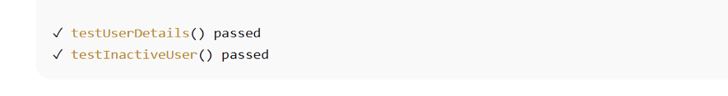

Exercise 4: Arrange-Act-Assert (AAA) Pattern

//CODE

@BeforeEach  
 void setUp() {  
 bankAccount = new BankAccount(1000);  
 }  
@Test  
 void testWithdraw() {  
 bankAccount.withdraw(100);  
 assertEquals(900, bankAccount.getBalance());  
 }

OUTPUT :

